

Functional Requirements Document

CPS-Tec Migrate FIDs Administration from SAPUF to Cyberark  
​

Version: ​Version 2.1

Date: 17/Feb/2020.

Lead Business Analyst: Martinez Ramirez, Alejandro [CCC-OT] AM47114

Business / Operations Sponsor: Sztabnik, William [CCC-OT] WS22453​

Sponsor Organization: Haua, Claudia [GCB-OT] CH76667​

BA Authors: Vega Olvera, Sukey [CCC-OT] SV07571​

Planview Number: P0149779​

Target Release: 2020-05-Wk4​

Work Request ID: ​ X-1788602

This page displays the U.S. Export Notice. Do NOT delete.

**US Export/Reexport Notice**

Any transfer of this information beyond a country’s border (or release to others in country knowing they are foreign nationals* or will transfer the information cross border) may require the prior approval of the U.S. Government as well as the country where it is located.  To ensure compliance with applicable requirements, please contact your local Export License Coordinator (ELC) for assistance: . <https://www.citi.net/EN/Pages/riskmanagement/ContentPages/ECU-Templates-and-Forms.aspx?src=/EN/operationsandtechnology/riskmanagement>. If you are unable to find your ELC please contact the Chief or the Senior ELC.  
*Non Citizen/non permanent resident.

**Table of contents**

Template Instructions 5

1 FR Change History 5

2 Project Information 6

**2.1** General Project Information 6

3 Scope Statement 7

**3.1** **Project Description/Objectives \*** 7

3.1.1 **Project Description/Objectives** 7

3.1.2 **Non-Financial Benefits \*** 7

3.1.3 **Method for Measuring Benefits \*** 7

**3.2** **Justification** 7

**3.3** **Assumptions \*** 7

**3.4** **Constraints \*** 7

**3.5** **Dependencies \*** 8

**3.6** **Acceptance Criteria * (Critical Success Factors)** 8

**3.7** **Impacted Portfolios** 8

**3.8** **Scope \*** 8

4 Features 9

5 Business Requirements Information 10

**5.1** **Business Process Diagrams** 10

**5.2** **Business Rules** 11

5.2.1 **Business Rule** 11

**5.3** **Business Requirements \*** 11

5.3.1 **Business Functions and Process Descriptions \*** 11

5.3.2 **Business Requirements (1..n) \*** 11

**5.4** **CITMS Mandatory Business Requirements \*** 11

5.4.1 **Reporting \*** 11

5.4.2 **Interface \*** 11

5.4.3 **Legal, Regulatory, Compliance, and Anti-Money Laundering Requirements \*** 12

5.4.3.1 Accessibility Requirements 12

5.4.4 **User Testing Requirements \*** 12

5.4.5 **COB Recovery Requirements \*** 12

5.4.6 **Data Transfer \*** 12

5.4.7 **List of UAT Stakeholders (Organizations which will perform UAT) \*** 13

5.4.8 **Perform Production Parallel Testing \*** 13

5.4.9 **Perform Production Assurance Testing (PAT) \*** 13

5.4.10 **Data Requirements \*** 13

5.4.11 **Are there any Cross Border Data Privacy Implications with this project? \*** 13

5.4.12 **Security Requirements** 14

**5.5** **Business UI Screens** 15

**5.6** **Other Business Diagrams** 16

6 Functional Requirements 17

**6.1** **Functional Textual Requirements** 17

6.1.1 **Functional Requirement** 17

**6.2** **Nonfunctional Requirements** 17

6.2.1 **Correspondence** 17

6.2.2 **Physical Requirement** 17

6.2.3 **Implementation** 17

6.2.4 **Attachment/Hyperlink** 17

6.2.5 **Recoverability** 17

6.2.6 **Design Constraint** 18

6.2.7 **Reliability/Fault Tolerance** 18

6.2.8 **Usability** 18

6.2.9 **Performance** 18

6.2.10 **Time Behavior** 18

6.2.11 **Supportability** 18

6.2.12 **Additional User Testing Requirements** 18

**6.3** **Business Rules (Functional)** 18

6.3.1 **Business Rule - Functional** 18

**6.4** **CITMS Mandatory Functional Requirements \*** 18

6.4.1 **Processing Inputs \*** 18

6.4.2 **Processing Outputs \*** 19

6.4.3 **Interfaces \*** 19

6.4.4 **Processing Requirements (prerequisites such as data requirements)\*** 19

6.4.5 **Legal, Regulatory, Compliance, and Anti-Money Laundering Requirements \*** 19

6.4.5.1 **Accessibility Requirements** 19

6.4.6 **Report and Screen Layouts \*** 19

6.4.7 **Archiving Requirements \*** 20

6.4.8 **Recovery Requirements (Continuity of Business) \*** 20

6.4.9 **Other Nonfunctional Requirements \*** 20

6.4.10 **PII Data** 20

6.4.11 **Data Requirements \*** 20

6.4.12 **Control / Security Requirements \*** 21

6.4.12.1 **User Provisioning** 21

6.4.12.2 **Key Management** 21

6.4.12.3 **Logging** 21

6.4.12.4 **Authentication** 21

6.4.12.5 **Authorization** 21

6.4.12.6 **Data Protection Security** 21

6.4.12.7 **Input Validation and Output Encoding** 21

6.4.12.8 **Error Handling** 21

6.4.12.9 **Session Management** 21

6.4.12.10 **Logging and Monitoring** 21

**6.5** **Actors** 22

**6.6** **Use Case Diagrams** 23

6.6.1 Use Case Diagram 23

**6.7** **Use Cases** 24

6.7.1 Use Case List 24

**6.8** **Detailed Use Cases** 25

6.8.1 **New Use Case 1** 25

**6.9** **UI Screens** 27

**6.10** **Additional Diagrams** 28

**New Domain Diagram 1** 28

7 Glossaries 29

**7.1** **Glossary of Acronyms** 29

**7.2** **Glossary of Terms** 29

# Template Instructions

The following template provides instructions that should be removed before finalizing the document including this section.

Instructions for Technology Mandatory projects: If your project is a technology mandatory project without any impacts to the application or it’s functionality, a template is available on the Blueprint Support Sharepoint site to assist you with filling out the necessary information: <https://consumershare.nam.citi.net/sites/GCTBPSUP/Document%20Templates/Forms/AllItems.aspx>

# FR Change History

| Name | Date of change | Owner of change | Description |
| --- | --- | --- | --- |
| FRD 2.0 | 15/11/2019 | Sukey Vega (SV07571) | Version 2.0 |
| FRD 2.1 | 17/02/2020 | Pedro Enrique Gonzalez Jaramillo (PG78733) | Version 2.1 |

# Project Information

## General Project Information

**List of Reviewers**

| ID | ROLE | NAME |
| --- | --- | --- |
| AM47114 | Project CISO Leader Reviewer | Martinez Ramirez, Alejandro [CCC-OT]Alejandro Martinez AM47114 |
| SV07571 | CISO Leader Reviewer | Vega Olvera, Sukey [CCC-OT] SV07571 |
| PG78733 | PM Reviewer | González Jaramillo, Pedro Enrique PG78733 |

**List of Approvers**

| ID | ROLE | NAME |
| --- | --- | --- |
| JE59148 | Approver | Escobar Jantes, Julio (JE59148) |
| BT56405 | Approver | Tongo Rivera, Beatriz (BT56405) |
| JH37855 | Approver | Hilerio Alfaro José Fernando (JH37855) |
| AP87831 | Approver | Pineda Torres, Alejandro (AP87831) |
| MR39423 | Approver | Rodriguez Gomez, Miguel (MR39423) |
| lt37931 | Approver | Tovar Escobar, Luis Manuel (lt37931) |

# Scope Statement

* 1. **Project Description/Objectives \*** 
     1. **Project Description/Objectives**

Project Description/Objectives

The objective of the project is to implement the global standard solution named Cyberark to manage in an automatic way the passwords between applications and it is aligned with security features that Citi has been defined to for manage passwords and it has a support model  for the onboarding and  BAU activities with global operating teams (GIDA, Security Operations and privileged identity management). And it is available for diverse platforms and versions that Citi has defined as standard solutions.  
Objectives:

• Migrate the FIDs administration from SAPUF system to Cyberak.

• Adopt the Cyberark global standard.

• Eliminate the operational risk posed by no longer having a support contract with current solution provider SAPUF.

• Incorporate new functionalities/capabilities to manage functional accounts and security.

• Retire Unisys and Tandem SAPUF Agents (suppliers).

* + 1. **Non-Financial Benefits**

The project is part of the Core Platform Simplification Program/Mx2020 strategy, therefore the non-financial benefit is about Control/Process Improvement/Simplification

* + 1. **Method for Measuring Benefits**

Review that the applications are no longer using the legacy SAPUF component in Production.  
​​

* 1. **Justification** 
     1. **Justification**

​ SAPUF is the functional ID´s password management system between applications used at Citibanamex, it is based on TANDEM platform, requires manual administration and is based on the legacy nomenclature about applications and it has not been adding functionality and support last platform versions (such operating systems and databases)  for the last 5 years.  
​

.

* 1. **Assumptions \*** 
     1. **Assumptions**

All Citibanamex applications that use SAPUF as mechanism to manage password of functional IDs. It is mandatory that the application is registered in Citi System Inventory (CSI) and the Functional ID is registered into the Central ISA Repository (CISAR).

* 1. **Constraints \*** 
     1. **Constraints**

**Activity constraints:**

Applications without vulnerability assessment that can affect the project timeline.

Applications that requires performance tests that can affect the project timeline.

**Time and Date constraints:**

2019-06-Wk4

**Resource constraints**:

Availably of resources for the development on the applications

**Budget constraints:**

There are budget constraints since the funds are already available.  
​

* 1. **Dependencies \*** 
     1. **Dependency**

There are no dependencies. The infrastructure is already available in NAM.

* 1. **Acceptance Criteria * (Critical Success Factors)** 
     1. **Acceptance Criteria**

The applications working correctly using CyberArk.​

* 1. **Impacted Portfolios** 
     1. **Impacted Portfolios {PI8745936}**

GCG and CTO impacted portfolios

* 1. **Scope \*** 
     1. **Scope**

|  |  |  |  |  |
| --- | --- | --- | --- | --- |
| CSI ID | NAME | Sector | SYSTEM TYPE | SYSTEM PLATFORM |
| 145791 | TARJETA CORPORATIVA (C430) | GCG | DATABASE | SYBASE |
| 163929 | Integral Process of Technical Dictamination | CTO | DATABASE | SYBASE |
| 145796 | SIAF (FRAUD CONTROL AND MANAGEMENT) | GCG | DATABASE | SYBASE |
| 145759 | Embossing and Delivery System (C104) | GCG | DATABASE | ORACLE |
| 159127 | CSIS-Mexico Security - Alarms and Video Monitoring System | CTO | DATABASE | MS QLSERVER |
| 147984 | Fiduciary Fess Application | ICG_Tech | DATABASE | SYBASE |
| 151630 | Bussinesses Control System and Treasury | ICG_Tech | DATABASE | SYBASE |
| 147983 | Trust Digital Files | ICG_Tech | DATABASE | SYBASE |
| 165699 | Account receivable discount web | GCG | DATABASE | ORACLE |

# Features

* 1. **Feature 1**

List each feature.  You may use folders in this section if necessary.

Trace Requirements:

|  |  |  |
| --- | --- | --- |
| CSI ID | NAME |  |
| 145791 | TARJETA CORPORATIVA (C430) |  |
| 163929 | Integral Process of Technical Dictamination |  |
| 145796 | SIAF (FRAUD CONTROL AND MANAGEMENT) |  |
| 145759 | Embossing and Delivery System (C104) |  |
| 159127 | CSIS-Mexico Security - Alarms and Video Monitoring System |  |
| 147984 | Fiduciary Fess Application |  |
| 151630 | Bussinesses Control System and Treasury |  |
| 147983 | Trust Digital Files |  |
| 165699 | Account receivable discount web |  |

# Business Requirements Information

## **Business Process Diagrams**

* + 1. **Business Process Diagram**

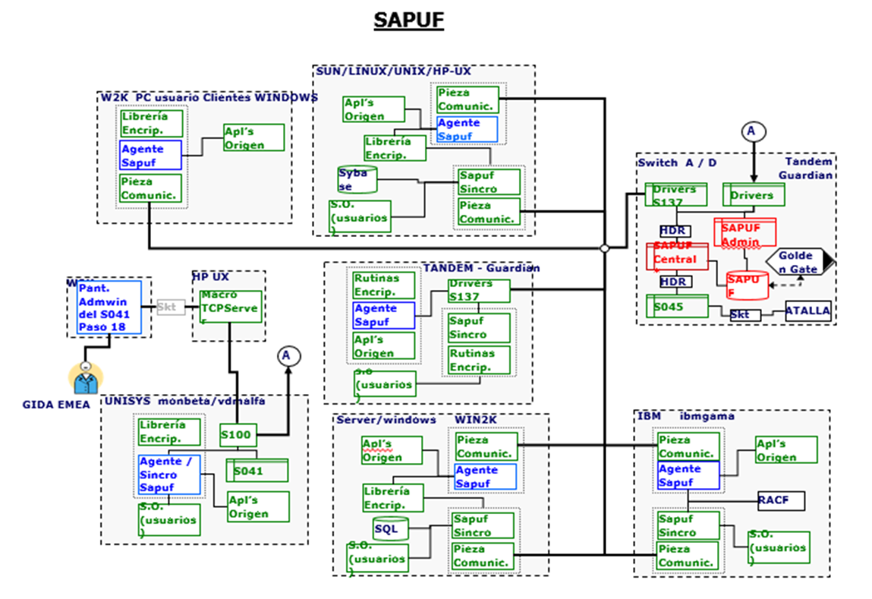

## **Business Rules**

### **Business Rule**

This folder contains business rules that are pertinent to the current project.  Business rules are optional.  If you have no business rules you may add "There are no business rules for this project." in the folder description.  (Artifact Type: Folder)

Business Rules are rules which do not fit into other categories, or are pure business rules. They could be a number of things.  The rule of thumb is that a BR is either a rule which would be in place whether or not a system existed, or a calculation of some kind related to a business function.

For example: "A Supervisor must provide an override in order for a CSR to delete a transaction", or "If a Customer has a credit score below 620 then an additional x% APR will apply to their credit card agreement".  It could also be any rule which requires a mathematical formula or algorithm to be complete.   Most business rules result in functional requirements or alternate flows in use cases.

Trace Requirements:

## **Business Requirements \***

### **Business Functions and Process Descriptions**

RU-0001 - Grouping accounts and applications to be migrated - The system must generate in T the file with pre-selected accounts and applications to be migrated  
RU-0002 - Provide segregation of duties between FID´s. - Configurable policies that enable organizations enforce granular privileged access controls, automate workflows and rotate passwords at a regular cadence without manual intervention.  
RU-0003 - Initiate onboarding with request to integrate with CyberArk AIM - Applications must satisfy prerequisites before onboarding  
RU-0004 - Config Files for App Server - There is default central configuration file main_appprovider.conf.<platform>.<version> created whenever Credential Provider is installed in Windows or Linux servers This file can be uploaded to Safe AppProviderConf through PrivateArk Client  
RU-0005 - Create CP User and generate initial cred file per app server. - CyberArk Administrator do by running CreateCredFile utility and generate appprovideruser.cred file and circulate that file to the application team.  
RU-0006 - Securely provide initial cred file to the application team - step need to be managed by application team , application team can run this utility in their environment after installing the credential provider agent  
RU-0007 - Configure Params file , install, RPM , Vault.ini , initial cred file - Configure params and start AIM Service for connect to CyberArk Vault and execute password reset on CP User and CP updates password in initial cred file  
RU-0008 - Create application user and authentication parameters - Application user must have OS user, path and authorized machines specified  
RU-0009 - Grant Application and CP Users retrieval access to the FID safe - GIDA will be grant access to the FID Safe  
RU-0010 - CP synchronizes passwords to local cache based on persistence settings - Configure application user account password policy to meet Citi’s standards.  
RU-0011 - Application will be ready for password retrieve - CMP initiates FID Account take over through password reset  
RU-0012 - Provide a detailed audit log that captures all activities of both functional and non-functional users. - Log below significant security administration events such as user creation, user access rights modification, password reset, security configuration changes

## **CITMS Mandatory Business Requirements \***

### **Reporting**

### RU-0012 - Provide a detailed audit log that captures all activities of both functional and non-functional users. - Log below significant security administration events such as user creation, user access rights modification, password reset, security configuration changes RU-0013 - Log Messages - To capture the following items in the log messages: - Appropriate timestamp (date, hours, minutes, seconds) - User ID - Event type - Affected resource - Access type - Action outcome RU-0014 - Log Events - Ability to capture the following events in the log: - Authentication events - Unsuccessful login - Successful login if requires to support forensic purpose - Account lockouts - Significant Security Administration events - User/group creation - Creation of application roles/profiles - Modification of roles/profiles - Modification of user access rights - Manual password reset - Infrastructure security related events - Changes to system security configuration - Manual change to the non-security related configuration which effects service function - Log integrity events - Manual log deletion of stoppage - Manual log modification

### **Interface \***

RU-0004 - Config Files for App Server - There is default central configuration file main_appprovider.conf.<platform>.<version> created whenever Credential Provider is installed in Windows or Linux servers This file can be uploaded to Safe AppProviderConf through PrivateArk Client

RU-0005 - Create CP User and generate initial cred file per app server. - CyberArk Administrator does this by running CreateCredFile utility and generating an appprovideruser.cred file and circulate that file to the application team.

RU-0006 - Securely provide initial cred file to the application team - step needed to be managed by the application team , the application team can run this utility in their environment after installing the credential provider agent

RU-0007 - Configure Params file , install, RPM , Vault.ini , initial cred file - Configure params and start AIM Service to connect to CyberArk Vault and execute password reset on CP User and CP updates password in initial cred file

RU-0008 - Create application user and authentication parameters - Application user must have OS user, path and authorized machines specified

RU-0009 - Grant Application and CP Users retrieval access to the FID safe - GIDA will have be grant access to the FID Safe

RU-0010 - CP synchronizes passwords to local cache based on persistence settings - Configure application user account password policy to meet Citi’s standards.

### **Legal, Regulatory, Compliance,Anti-Money Laundering and Records Management Requirements \***

NA. It does not apply; it is a technology project, only about to replace a security legacy component to a new standard in Citibanamex

#### Accessibility Requirements

​ NA. It does not apply; it is a technology project, only about to replace a security legacy component to a new standard in Citibanamex

### **User Testing Requirements \***

RU-0007 - Configure Params file , install, RPM , Vault.ini , initial cred file - Configure params and start AIM Service to connect to CyberArk Vault and execute password reset on CP User and CP updates password in initial cred file.​

### **COB Recovery Requirements \***

Replicate production CyberArk component on the COB environments, this is a global infrastructure

### **Data Transfer \***

NA. It does not apply; there is not any data transfer consider on the project. It is only about to replace a security legacy component to a new standard in Citibanamex and CyberArk does not transfer customer data.

### **List of UAT Stakeholders (Organizations which will perform UAT) \***

ESCOBAR JANTES, JULIO (JE59148) [145791,145759]

TONGO RIVERA, BEATRIZ (BT56405) [163929]

HILERIO ALFARO, JOSE FERNANDO (JH37855) [145796]

PINEDA TORRES, ALEJANDRO (AP87831) [159127]

TOVAR ESCOBAR, LUIS MANUEL (LT37931) [165699]

RODRIGUEZ GOMEZ, MIGUEL (MR39423) [147983,147984,151630]

.

### **Perform Production Parallel Testing \***

NA. It does not apply; there is not impact on the applications performance. It is only about to replace an agent to manage the FID password

### **Perform Production Assurance Testing (PAT) \***

Production Assurance Testing :  A type of Testing where production data may be used in a pre-production environment which is intended to have controls/setup similar to Production. PAT allows the End User to perform a final check on core/critical end- to- end Business processes, volume, accuracy, interfaces, etc. based on business requirements using production data. Production Assurance Testing usually occurs after formal acceptance of the system from UAT but may be combined with end user testing (UAT).  
Respond Yes or No in the description.  An explanation is NOT required for a NO answer. ​

Trace Requirements: NO.

|  |  |  |
| --- | --- | --- |
| CSI ID | NAME |  |
| 145791 | TARJETA CORPORATIVA (C430) |  |
| 163929 | Integral Process of Technical Dictamination |  |
| 145796 | SIAF (FRAUD CONTROL AND MANAGEMENT) |  |
| 145759 | Embossing and Delivery System (C104) |  |
| 159127 | CSIS-Mexico Security - Alarms and Video Monitoring System |  |
| 147984 | Fiduciary Fess Application |  |
| 151630 | Bussinesses Control System and Treasury |  |
| 147983 | Trust Digital Files |  |
| 165699 | Account receivable discount web |  |

### **Data Requirements \***

RU-0012 - Provide a detailed audit log that captures all activities of both functional and non-functional users. - Log below significant security administration events such as user creation, user access rights modification, password reset, security configuration changes

RU-0013 - Log Messages - To capture the following items in the log messages: - Appropriate timestamp (date, hours, minutes, seconds) - User ID - Event type - Affected resource - Access type - Action outcome

RU-0014 - Log Events . Ability to capture the following events in the log: - Authentication events - Unsuccessful login - Successful login if requires to support forensic purpose - Account lockouts - Significant Security Administration events - User/group creation - Creation of application roles/profiles - Modification of roles/profiles - Modification of user access rights - Manual password reset - Infrastructure security related events - Changes to system security configuration - Manual change to the non-security related configuration which effects service function - Log integrity events - Manual log deletion of stoppage - Manual log modification.​

### **Are there any Cross Border Data Privacy Implications with this project? \***

### There is no any impact on the crossborder data privacy. Security Operations will comment if there is a clearance for Mexico, if not we will open a request. Important to comment that CyberArk is not managing a customer passwords but it manage the Functional IDs password for that we will have that clearance

### **Security Requirements**

RU-0009 Grant Application and CP Users retrieval access to the FID safe - GIDA will have grant access to the FID Safe.

RU-0010 CP synchronizes passwords to local cache based on persistence settings - Configure application user account password policy to meet Citi’s standards.

RU-0011 Application will be ready for password retrieval - CMP initiates FID Account takeover through password reset.

## **Business UI Screens**

**Business UI Screen**

|  |  |  |
| --- | --- | --- |
| CSI ID | NAME | Architecture Diagram |
| 145791 | TARJETA CORPORATIVA. (C430) |  |
| 163929 | Integral Process of Technical Dictamination |  |
| 145796 | SIAF (FRAUD CONTROL AND MANAGEMENT) |  |
| 145759 | Embossing and Delivery System (C104) |  |
| 159127 | CSIS-Mexico Security - Alarms and Video Monitoring System |  |
| 147984 | Fiduciary Fess Application |  |
| 151630 | Bussinesses Control System and Treasury |  |
| 147983 | Trust Digital Files |  |
| 165699 | Account receivable discount web |  |

## **Other Business Diagrams**

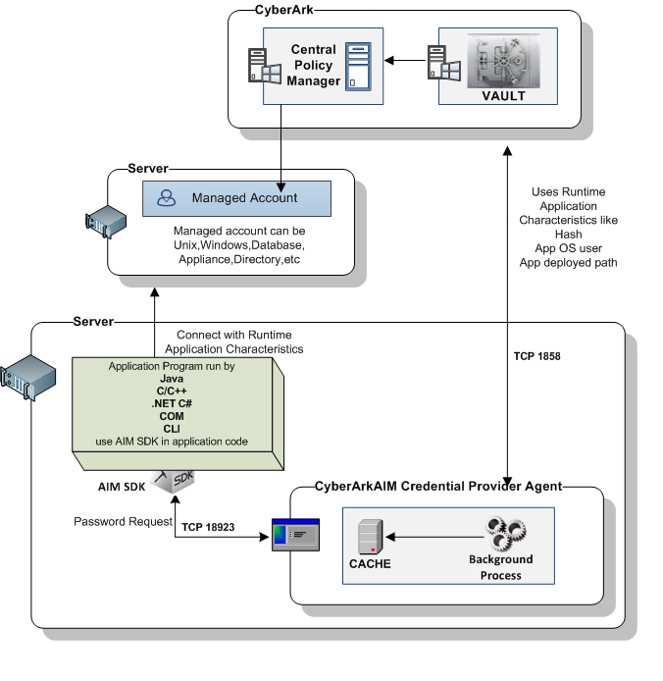

# Functional Requirements

## **Functional Textual Requirements**

This folder contains all information associated with the functional requirements portion of an FR document.  This includes textual requirements, use cases, actors, use case diagrams, and UI screens.

### **Functional Requirement**

**163929 Integral Process of Technical Dictamination**

**159127 CSIS-Mexico Security - Alarms and Video Monitoring System**

**145791 TARJETA CORPORATIVA (C430)**

**145759 Embossing and Delivery System (C104)**

**145796 SIAF (FRAUD CONTROL AND MANAGEMENT)**

**165699 Account receivable discount web**

**147984 Fiduciary Fess Application**

**151630 Businesses Control System and Treasury**

**147983 Trust Digital Files (c659)**

FR001 Onboarding FID

FR1.1 Onboarding FID

FR1.2 Register new FID

FR002 Analysis of Cyberark Implementation

FR2.1 Review ok Cyberark documentation

FR2.2 Identify participating areas

FR2.3 Define Onboarding processes to follow

FR003 Identification of application settings

FR3.1 Analysis of App impact (Batch)

FR3.2 Analysis of App Impact (Front)

FR3.3 Identify modules to modify (Batch)

FR3.4 Identify modules to modify (Front)

FR004 Cyberark Settings

FR4.1 Get components (CyberArk)

FR4.2 Install components CyberArk (Batch)

FR4.3 Configuration of components (Batch)

FR4.4 Install components in App Server

FR4.5 Configuration of App Server to para sync password

FR005 App Settings

FR5.1 Elaborate / Update Manuals (Front)

FR5.2 Elaborate / Update Manuals (Batch)

FR5.3 Modify impacted Modules (Batch)

FR5.4 Modify impacted Modules (Front)

FR5.5 Create FID Catalogos…c808_Catalogos

FR5.6 Create FID Catalogos…c404_Catalogos

FR5.7 Unit Tests (Batch)

FR5.8 Unit Tests (Front)

FR006 Tests in SIT and UAT environments

FR007 Installation in production environment

## **Nonfunctional Requirements**

Requirements that add quality attributes to the system.

### **Correspondence**

Development requirements do not consider information related to correspondence.

### **Physical Requirement**

The use of new servers to implement the applications is not considered  
​

### **Implementation**

The current release process should be used.

### **Attachment/Hyperlink**

NA

### **Recoverability**

If Cyberark fails, it will automatically reboot in COB without direct application intervention.

### **Design Constraint**

• Not having the environment ready for the development of the requirement.

• Not having the correct architecture to execute the implementation.

• Failure to complete user tests due to development over time.

• Not having the necessary resources for the implementation of the project.  
​

### **Reliability/Fault Tolerance**

There are no processes that alter fault tolerance or system.  
​

### **Usability**

A generic CyberArk solution will be used, to implement the obtaining of the password of the FID to be signed to the database engine.  
​

### **Performance**

​NA. It does not apply; it is a technology project, only about to replace a security legacy component to a new standard in Citibanamex

### **Time Behavior**

​NA. It does not apply; it is a technology project, only about to replace a security legacy component to a new standard in Citibanamex

### **Supportability**

NA. It does not apply; it is a technology project, only about to replace a security legacy component to a new standard in Citibanamex

### **Additional User Testing Requirements**

|  |  |  |
| --- | --- | --- |
| **Region** | **Requirements to test** | **Testing New or changed Functionality** |
| Mexico-Latam | Migrate FID´s from SAPUF to CYBERARK in the following APPs.:  **163929 Integral Process of Technical Dictamination**  **159127 CSIS-Mexico Security - Alarms and Video Monitoring System**  **145791 TARJETA CORPORATIVA (C430)**  **145759 Embossing and Delivery System (C104)**  **145796 SIAF (FRAUD CONTROL AND MANAGEMENT)**  **165699 Account receivable discount web**  **147984 Fiduciary Fess Application**  **151630 Businesses Control System and Treasury**  **147983 Trust Digital Files (c659)** | New |

## **Business Rules (Functional)**

### **Business Rule - Functional**

It does not apply.   
​

## **CITMS Mandatory Functional Requirements**

### **Processing Inputs**

### The user will sign in to the application and completing its validation process will send the required information to the CyberArk library to retrieve the password of the database engine.​

### **Processing Outputs**

​NA. It does not apply; it is a technology project, only about to replace a security legacy component to a new standard in Citibanamex

​

### **Interfaces**

​NA. It does not apply; it is a technology project, only about to replace a security legacy component to a new standard in Citibanamex

​

### **Processing Requirements (prerequisites such as data requirements)**

Obtaining the password in Cyberark library.

​

### **Legal, Regulatory, Compliance, and Anti-Money Laundering Requirements**

NA. It does not apply; it is a technology project, only about to replace a security legacy component to a new standard in Citibanamex

​

#### **Accessibility Requirements**

NA. It does not apply; it is a technology project, only about to replace a security legacy component to a new standard in Citibanamex

​

### **Report and Screen Layouts**

​NA. It does not apply; it is a technology project, only about to replace a security legacy component to a new standard in Citibanamex

### **Archiving Requirements**

​NA. It does not apply; it is a technology project, only about to replace a security legacy component to a new standard in Citibanamex

### **Recovery Requirements (Continuity of Business)**

Currently there is a traditional level of business continuity; this means that in case of failure, the service must be restored in less than 72 hours.

It is beyond the scope of this project to modify the level of business continuity of the applications.

### **Other Nonfunctional Requirements**

​NA. It does not apply; it is a technology project, only about to replace a security legacy component to a new standard in Citibanamex

### **PII Data**

NA. It does not apply; it is a technology project, only about to replace a security legacy component to a new standard in Citibanamex

### **Data Requirements**

The passwords of the FID’s will be protected by CyberArk.

### **Control / Security Requirements**

#### **User Provisioning**

NA

#### **Key Management**

NA  
​

#### **Logging**

NA.

#### **Authentication**

The FID´s will be authenticated via Cyberark.

#### **Authorization**

NA.

#### **Data Protection Security**

NA

#### **Input Validation and Output Encoding**

NA

#### **Error Handling**

NA

#### **Session Management**

NA

#### **Logging and Monitoring**

NA

## **Actors**

| ID | Name: | Description: |
| --- | --- | --- |
|  | Actor | Application FID´S:  ​   * DEV * UAT * PROD * COB ​ |

## **Use Case Diagrams**

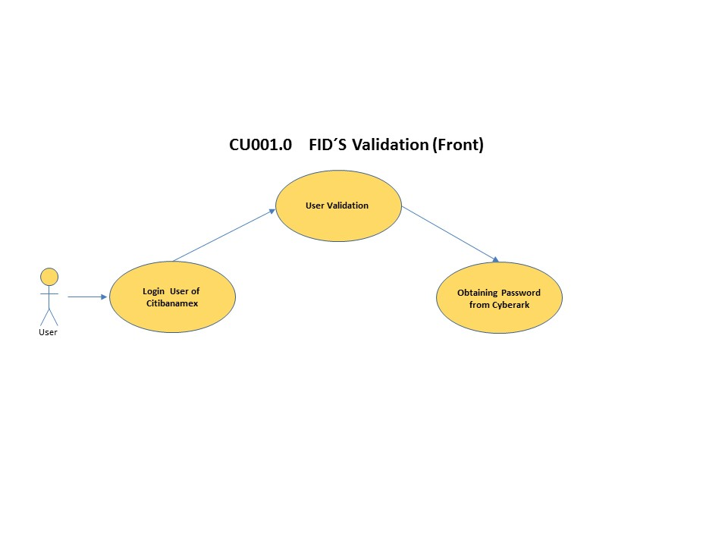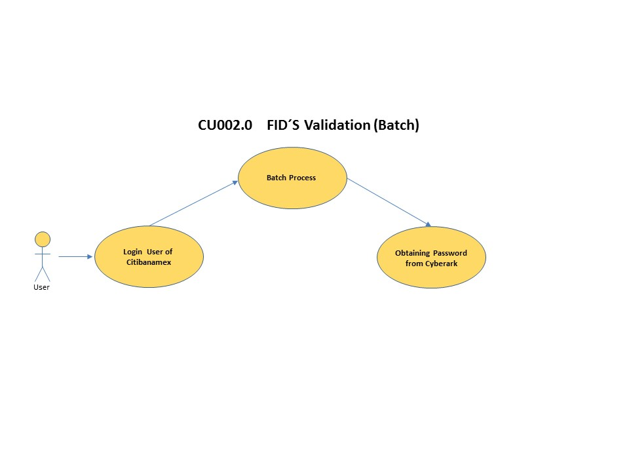

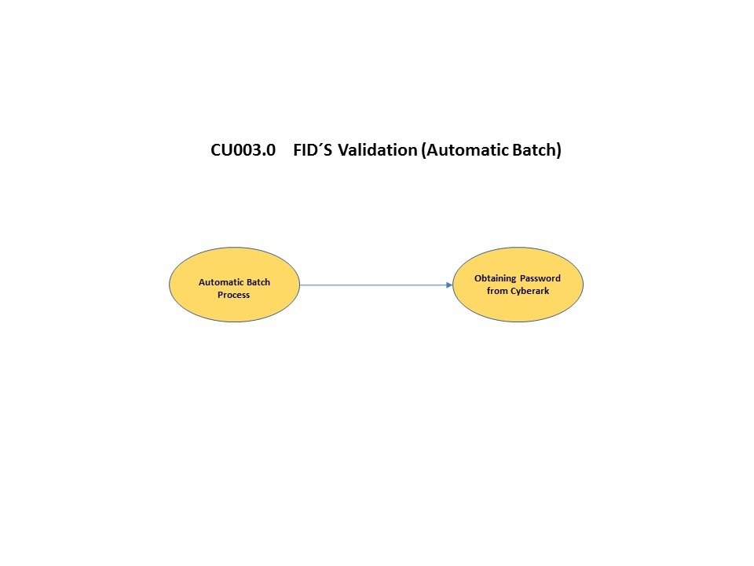

## **Use Cases**

### Use Case List

The Use Case List provides a quick overview of all Use Cases referenced in this project and in which folder in this project the Use Case appears. In some cases, Use Cases from other projects may be included in one of this project’s use cases or traced to from a requirement in this project; if so, the Use Case and External Project is identified, but the use case detail is not.

| **ID** | **Name** | **Parent Folder** | **Description** |
| --- | --- | --- | --- |
|  | FID´s Validation | **Use Cases** | CU001.0 The user will sign in to the application and completing its validation process will send the required information to the CyberArk library to retrieve the password of the database engine. |
| CU002.0 The user will sign in to the application and the batch process will send the required information to the CyberArk library to retrieve the password of the database engine. |
| CU003.0 The batch process will send automatically the required information to the CyberArk library to retrieve the password of the database engine. |
|  | | | |

## **Detailed Use Cases**

### **CU001.0 FID´s Validation**

• CU001.0 The user will signs in the application and completing its validation process will send the required information to the CyberArk library to retrieve the password of the database engine.

• CU002.0 The user will signs in the application and the batch process will send the required information to the CyberArk library to retrieve the password of the database engine.

CU003.0 The batch process will send automatically the required information to the CyberArk library to retrieve the password of the database engine.

Automatic Batch Process

User Validation

Login User of Citibanamex

YES

YES

NO

NO

END

Valid Password?

Correct Login to System

Obtaining password from Cyberark

Valid User?

START

|  |  |
| --- | --- |
| **Pre Condition** | **Login to the Application** |
| **Post Condition** | **Password´s validation in Cyberark** |
| **Related Requirements** |  |
| **Status** |  |

**Basic Flow:**

| **#** | **Description** | **Step Of** | **Screen** |
| --- | --- | --- | --- |
| 1a. | Login​ User of Citibanamex | Actor |  |
| 1b. | Automatic Batch Process  **Pre-Condition:** This process runs automatically in the app.  **Post- Condition:** Step 3. | Actor |  |
| 2. | User Validation  ​  **Condition:** Valid User  **Return Step:** Login​ User of Citibanamex | Actor |  |
| 3. | Obtaining password from Cyberark​  **Condition:** Valid Password  **Return Step:** Start | Actor |  |
| 4. | Correct Login to System | Actor |  |
| **SUCCESS END** | | | |

Back to Use Case List

## **UI Screens**

NA

# Glossaries

## **Glossary of Acronyms**

​

| Term | Description |
| --- | --- |
| FID | Functional ID |
| SAPUF | Sistema de Administración de Passwords de Usuarios Funcionales |

## **Glossary of Terms**

​

| Term | Description |
| --- | --- |
| Login | The entering of identifier information into a system by a user in order to access that system |